Containerized v-profile web application in multistage docker compose

First clone vprofile project from git using below command
git clone https://github.com/Abhijeet41/vprofile-project.git -b containers

now navigate to dockerfiles and write docker command for app
cd /Docker-files/app
vim Dockerfile
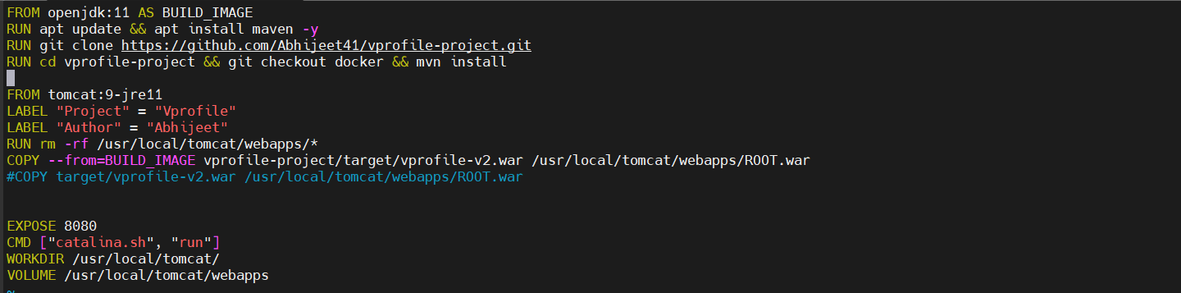

Note:
In this OpenJdk Image first we install open jdk and install app update then we clone source code from docker branch and using cd we navigate to vprofile-project and run mvn install so basically in this image we are generating artifact
In this TomCat Image you will be having default artifacte so far we need to remove it then copy .war file from above image path location. Expose port 8080 because tomcat run process on port
8080.

Setup Database
Now navigate to db folder and write docker commands to create mysql database

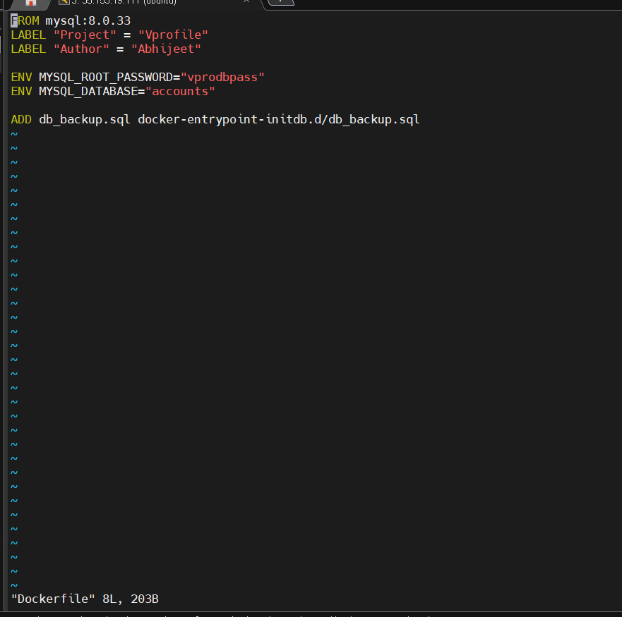

Now create Nginx image for web
Navigate to the web folder and edit Dockerfile

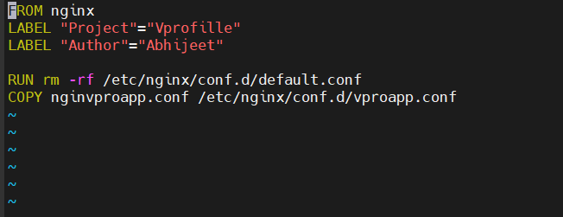

From nginx is default image name
give label as project and auther its optional

Note
We are building our own conf file i.e nginvproapp.conf
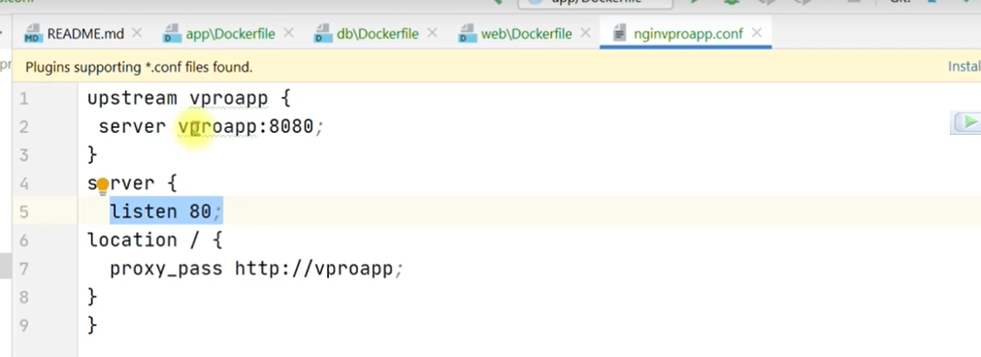
remove existing default.conf file then copy nginvproapp.confg // this info we will get from
official nginx image read the instruction carefully.

Now create and edit docker compose file

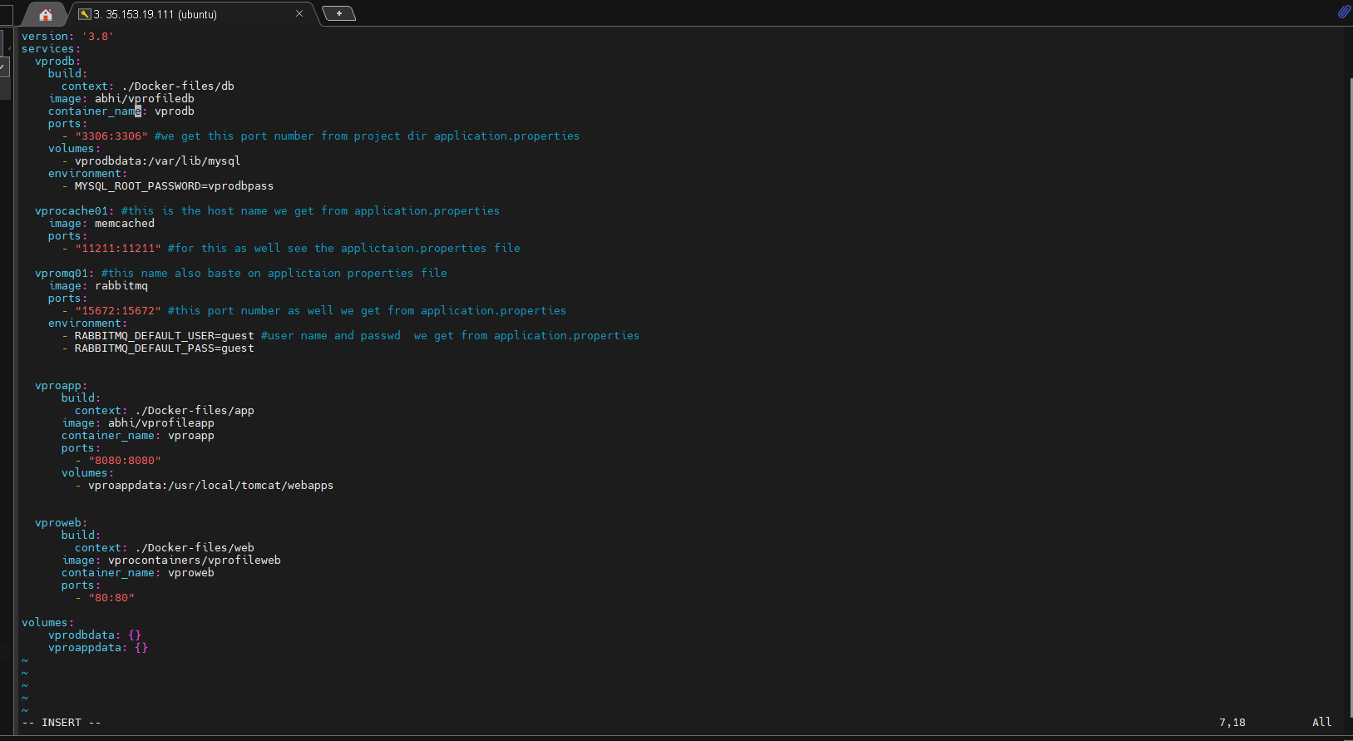

Above docker compose file we create from official docker compose references and the port we are using in this project itself application.properies
We are also getting environment username and password from application.properties

Now Build & Run Our Docker compose file using below command

First navigate to directory were compose.yaml file is present and type this command
docker compose build
o/p:- successfully build our image
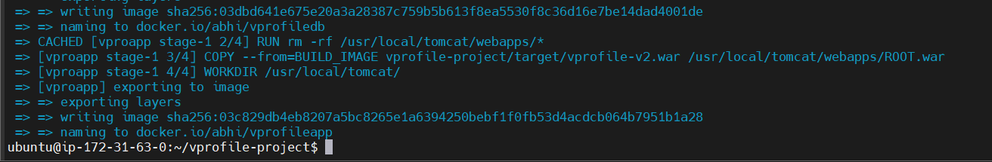
Make sure this 3 images get created
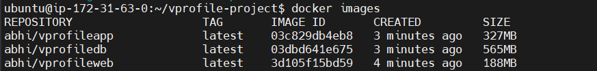

To start docker compose container use below command
docker compose up -d

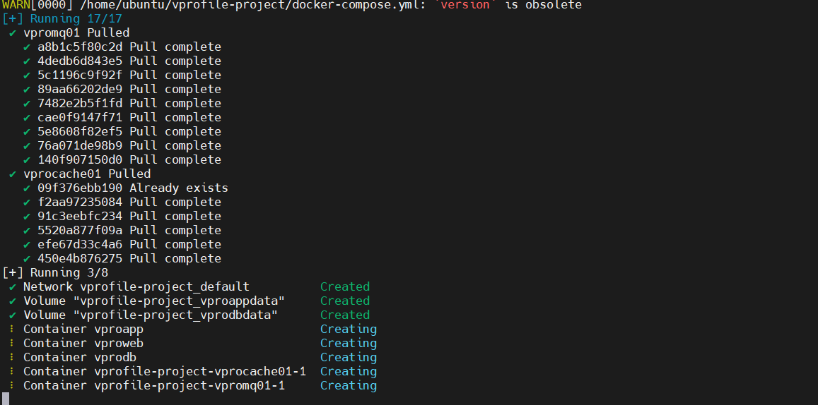

Use docker ps command to check all containers are working
docker ps -a
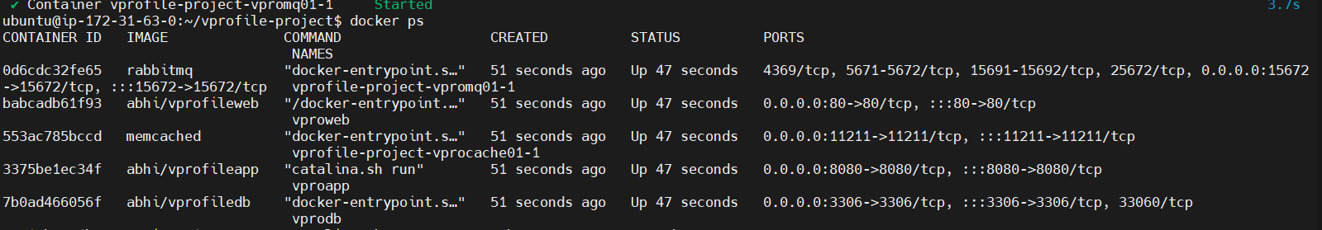

Now test on borwser weater its working or not

Now in browser type your_ip:8080 you get login page

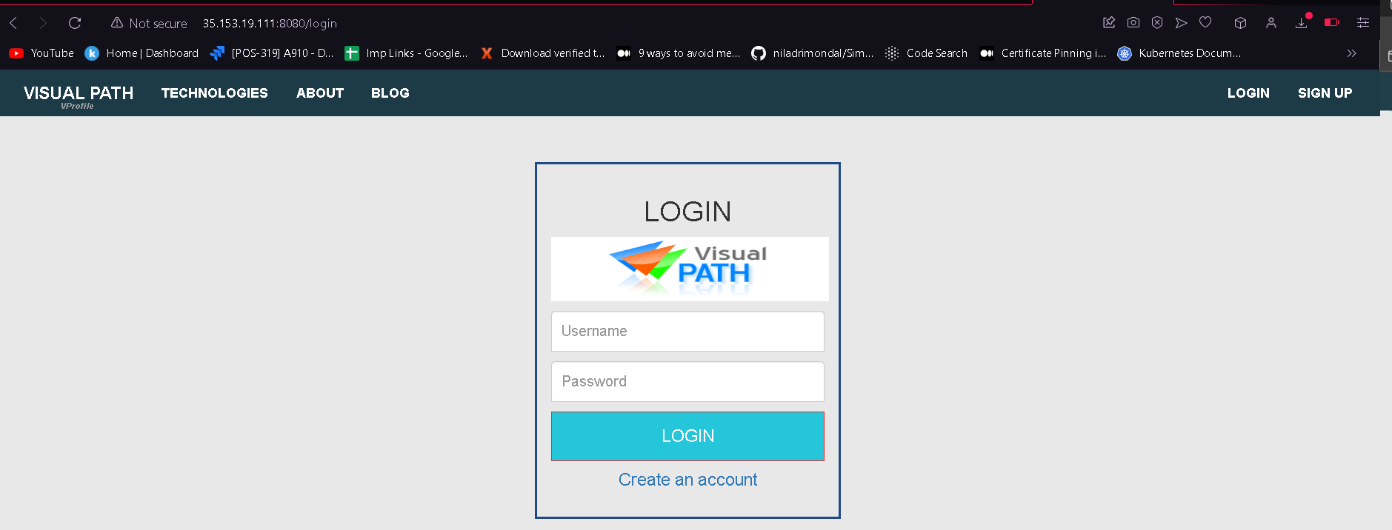

Loginid and password is same
Login id = admin_vp and password = admin_vp
If we able to login the consider your database container also working fine

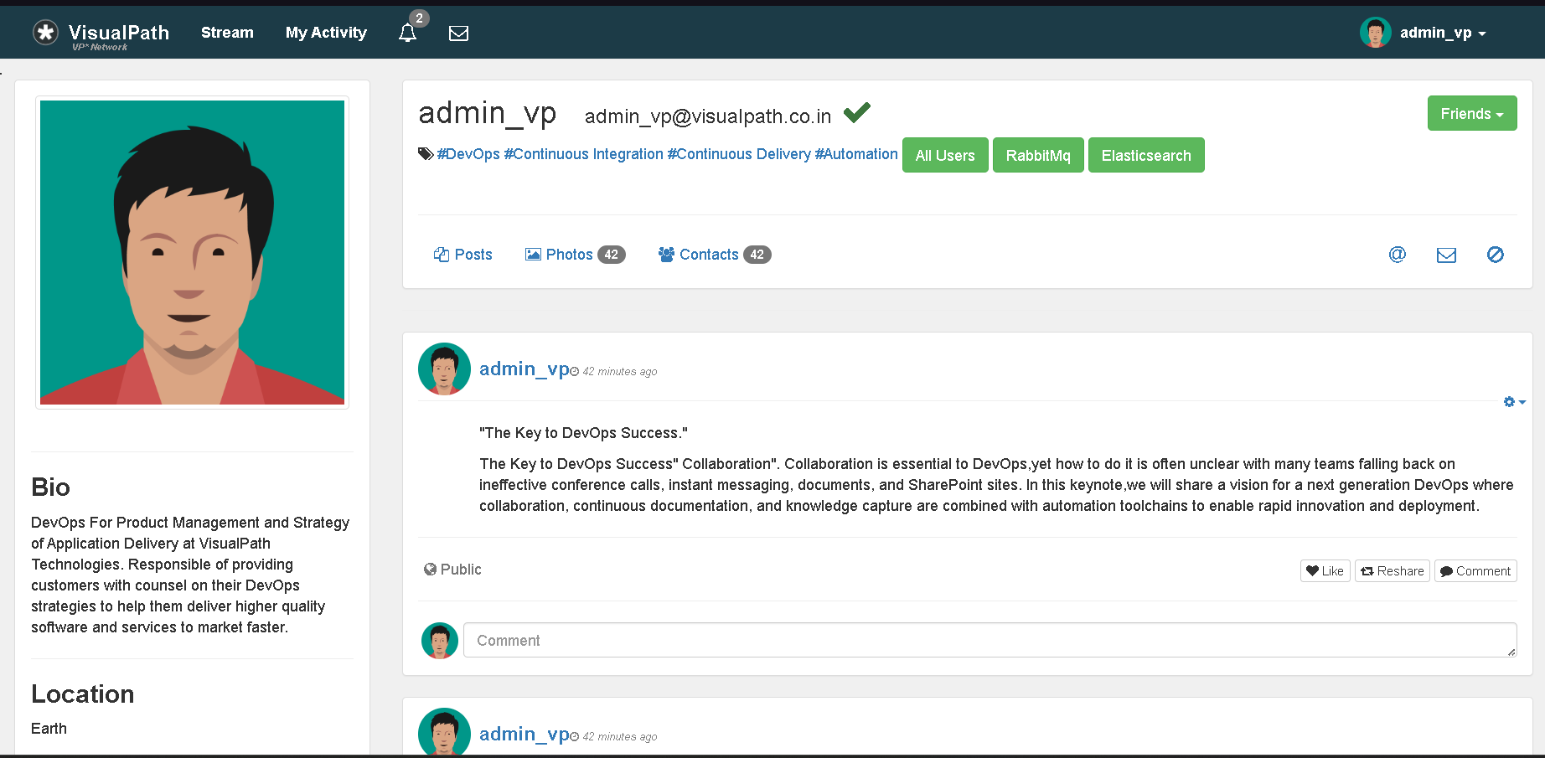

Now click on rabbit_mq button in website
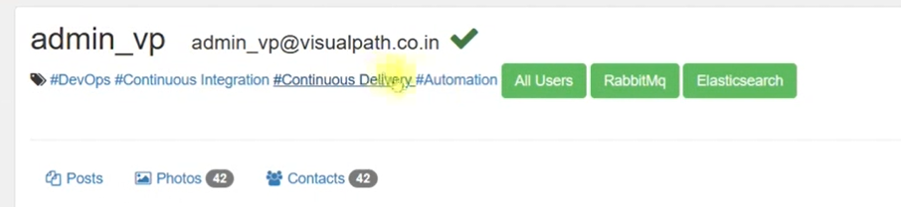

o/p

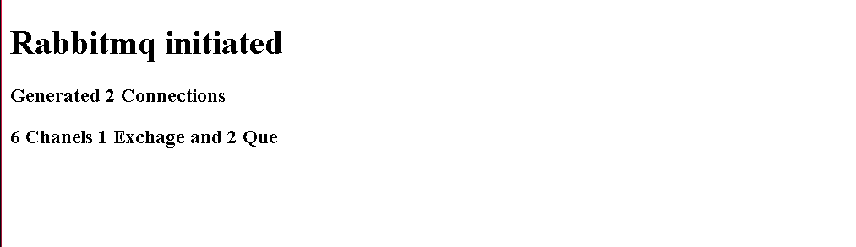
Check memcache workig or not by clicking all users button

o/p
